Q1. Design a web page by using HTML/CSS as shown below

Use media query to make the page responsive, the content must be displayed in one column for the small screen device.
Q2. Create a table in HTML/CSS as shown below
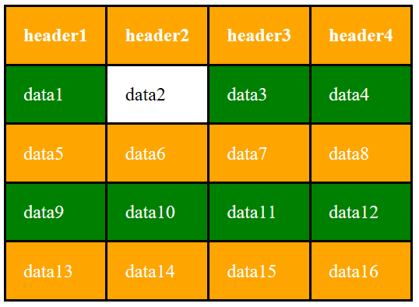
Use zebra striping for the table rows, and highlight the table data when the cursor is placed over it.

Q3. Design a registration form by using HTML/CSS as shown below
